**Salmon leggings with scrunch butt**

**The new collection of the renowned Nebbia manufacturer includes salmon leggings with scrunch butt. More about them in the article. We invite you to read.**

**Leggings and other sportswear**

Physical activity is not only a hobby or a trend but a way to extend life, improve our body's work and fight stress and other ailments of the 21st century. Many of us train in the gym, use organized activities such as fitness, yoga, company dance or pilates or boxing or crossfit. However, every active woman knows that in order to feel at ease while performing these sports activities it is worth taking care of the right outfit. It is thanks to him that not only uncomfortable pants or poor sports underwear, they will not restrict our movements but will also affect our self-esteem. Because clothes shaping the figure will make us look great - even during training! Understanding the needs of modern women, the Nebbia brand has created a special fashion for sports pants, the catalog includes, among others, [salmon leggings with scrunch butt](https://nebbiafitness.com/en/leggings-pants/2445-high-waist-scrunch-butt-leggings-model-n604-salmon-nebbia.html).

**Salmon leggings with scrunch butt made by Nebbia**

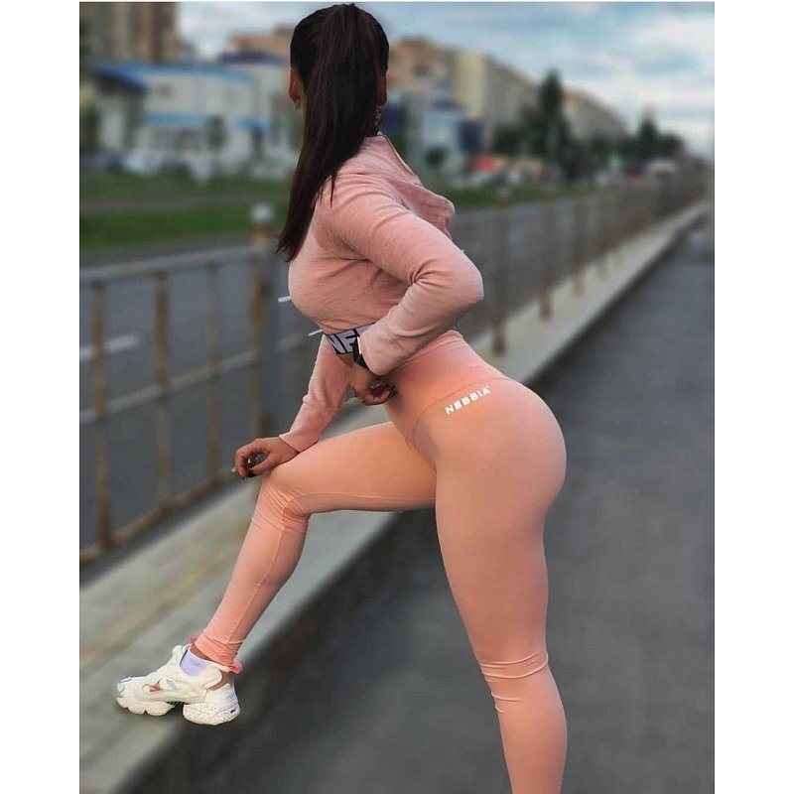

The **salmon leggings with scrunch butt** we offer is a model with a higher state. So they are perfect for fitness or pilates and yoga, where our body takes many, complicated figures. Leggings will adhere perfectly to the body, they will not fall. In addition, the V-shaped notch will slim out the stomach and lengthen the legs. Special hems on the back of leggings shape our buttocks.