**Bathing bra N631 black - for those, who like minimal things.**

**If you are one of those people who like to look like a minimalist but classy model, bathing bra N631 black is an option for you! In our short article, we explain why you should bet on the classics.**

**Black and other simple things**

Certainly not once you met with the situation when browsing magazines and blogs about fashion you decided to suggest the current trends and bought a fashionable thing, that was absolutely not in your style. You founded it once, maybe two because, unfortunately, you did not feel comfortable in it. To avoid such situations, it is worth being faithful to your style or betting on simple, elegant and classic solutions. **Bathing bra N631 black** is certainly one of them!

**Bathing bra N631 black - minimalism and effective classics**

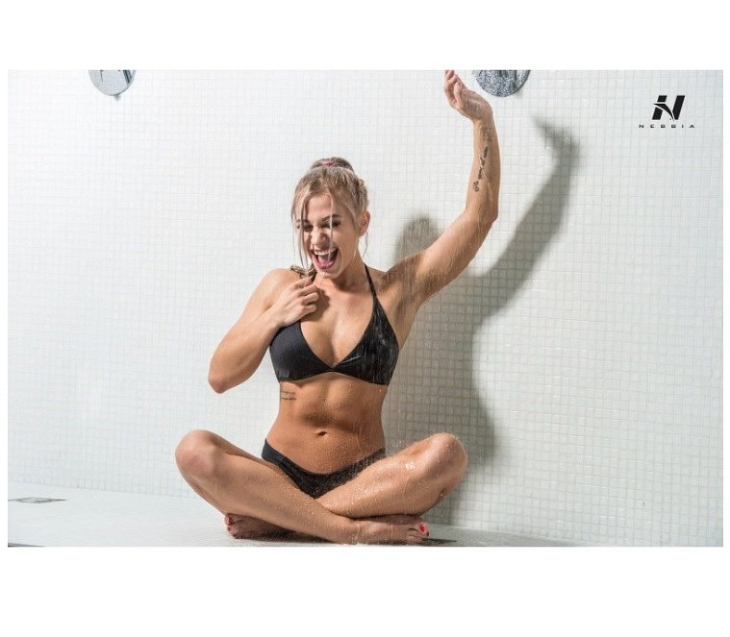

Summer and spring is the time when many of us plan trips for the weekend, to the water to rest. In summer, we sit by the pool, lake, sea to cool down a little and use the sunny weather in 100%. Do you want to emphasize the advantages of your body while presenting yourself with the class? Nebbia Fitness [bathing bra model N631 black](https://nebbiafitness.com/en/mini-singlets-bras/2451-bra-bathing-model-n631-black-nebbia.html) will provide you with this effect. Black is a shade that suits both brunettes, blonde and redheads. If your hair is different colors - pink, green, blue, silver - also black swimsuit is the solution for you!