**Men's workout t-shirts - we suggest which one to choose**

**Do not know which men's workout t-shirts you buy? In our article, we suggest which models are best to choose.**

**Workout and gym**

We live in a world where external appearance is very important. Because of this, many of us spend long hours in intensive training at the gym, running or practicing various sports. Given the way we live, we need to prepare for it. The first thing to think about is choosing the right sportswear that will enable us to do all the exercises comfortably. An essential element will be the [men's workout t-shirts](https://nebbiafitness.com/en/169-t-shirts-singlets).

**Men's workout t-shirts - which to buy?**

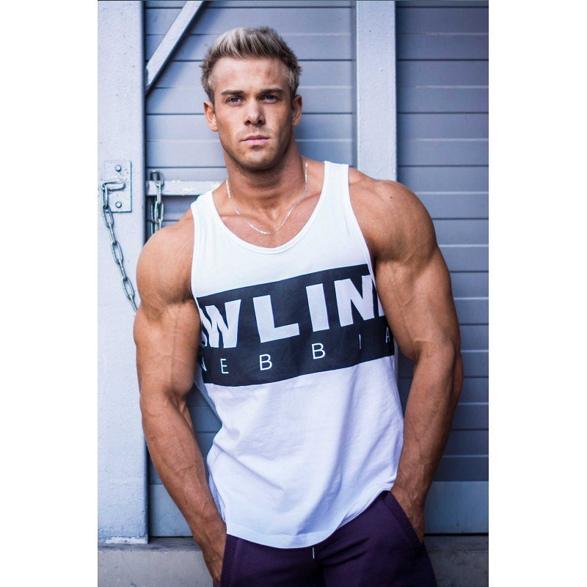

Each of the physical activities aims to increase our strength, improve the condition and give our muscles endurance. Therefore, doing exercises greatly increases the temperature of our body, which is why we are so warm. So if you ask us which **men's workout t-shirt**s to choose, we answer: those strapless. They will not constrain the movements during trainings, they will also display our trained bodies at the same time. We recommend the ones that were produced by the well-known sports brand Nebbia. Just go to their website to find the right t-shirt.