**Mini top n223 melange grey. Why You should have him?**

**Mini top n223 melange gray from Nebbia Fitness online catalog. Check in our article if this is a product for you**

**Top for a gym and other clothes**

It's no secret that fashion also applies to the gym or other sports such as crossfit, yoga or boxing. Many of us devote a lot of our free time to taking care of our figure and healthy body, so it's no wonder that we also want to look good and feel good in the four walls of the gym. Nebbia Fitness is a clothing brand that combines both modern, fashionable design and attention to comfort. Thanks to the use of special cuts to dress for both men and women, our clothes emphasize the figure and cover the shortcomings such as a protruding tummy. Today we would like to draw your attention to the women's product - [mini top n223 melange gray](https://nebbiafitness.com/en/mini-singlets-bras/1315-mini-top-melange-model-n223-grey-nebbia.html).

**Mini top n223 melange grey designed by Nebbia Fitness**

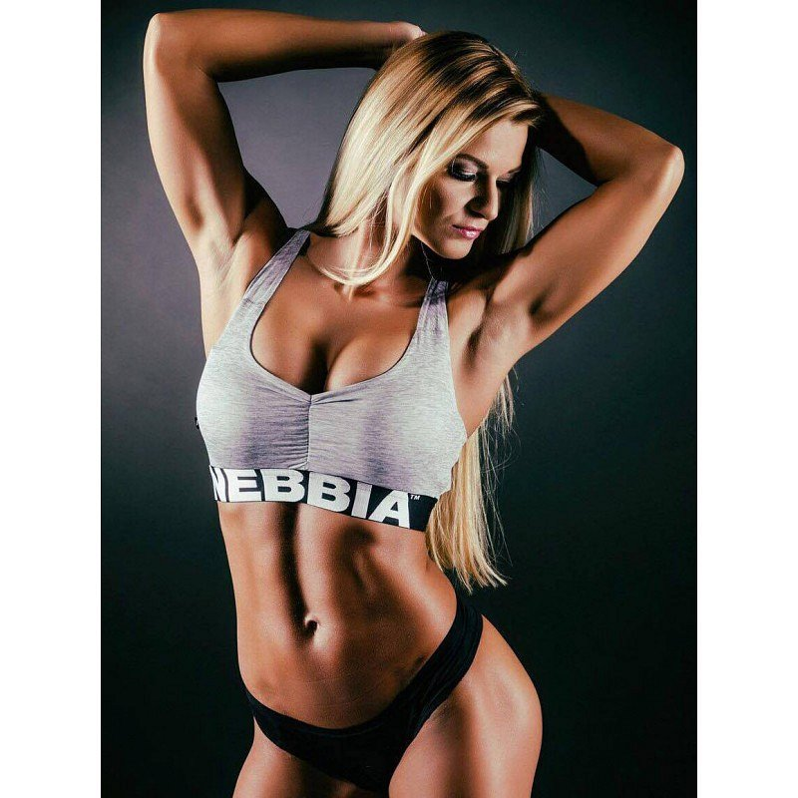

Mini top is a proposal for women, who are not ashamed of their body. The top cut exposes the bust and shoulders as well as the waist and stomach. **Mini top n223 melange gray** looks great with high-waisted leggings. By dressing in this way we will slim your waist, we will also pay attention to the buttocks. What's more, the mini top will ensure that we do not overheat our body during extremely intense trainings.