**Workout pants - needful for gym experience**

**Workout leggings from Nebbia is something really worth a try on. Why?**

**How are workout pants needed, anyway**

Well, one of the hottest topics about the gym activities in general out there are those which discuss motivation and the numerous perceived obstacles.

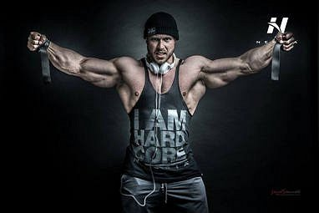

So, having a gym clothing of any kind that would not totally encourage you to do your best and go extra limits in your *workout* routine, is an important thing. So, what can we do about it? Nebbia Fitness has been designing and manufacturing and being interested in bodybuilding ever since it was founded as a company. This is why **workout pants** are, according to us, needed, anyway.

**Story of Nebbia**

Therefore, what has been our goal since then, was helping people who are into bodybuilding that is next to professional, but also those who just from time to time pop into a gym for their regular workout, which is maybe a way to boil down the stress - for each of thee types of gym users, we've got gym clothing - workout leggings being one product, but also many complete lines of clothes.

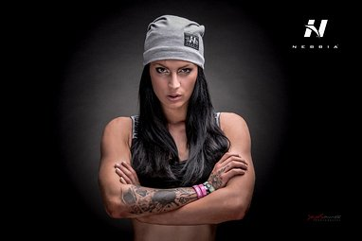

Check out *workout pants*, leggings and other clothes from Nebbia Fitness!

[nebbiafitness.com](http://nebbiafitness.com/)