**Black leggings with v butt and You are ready for a gym!**

**Black leggings with v butt and others slimming products from the nebbia fitness online store. More about this in the article below.**

**Leggings for people with a round figure**

Many of us have promised ourselves that these holidays were the last when we are ashamed to put on a short skirt or dress, or denim shorts or a swimsuit. If you are one of these people, you definitely decided to go on a healthy diet with the beginning of autumn and bring activity to your life, exercise regularly. Surely you know that to attend fitness, yoga, crossfit classes or just to train in the gym likes running, you need sports equipment. It is not only worth paying attention to what materials your sports underwear, shirt, sweatshirt or pants will be made of, but also whether they are fashionable. Thanks to this, you will feel much better during exercise, even if you have a few kilograms of excess weight. [Black leggings with v butt](https://nebbiafitness.com/en/leggings-pants/2442-leggings-v-butt-model-n605-black-nebbia.html) from the nebbia fitness collection is certainly one of those products. in which you not only cover the protruding belly but also model other parts of the body, additionally feeling at ease.

**Black leggings with v butt designed by Nebbia Fitness**

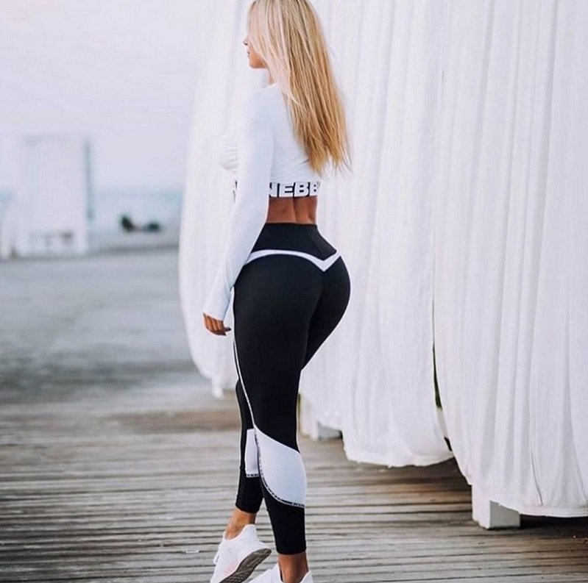

In the Nebbia Fitness online store you will find not only **black leggings with v butt** but also many other products that have the right profiling, thanks to which we will optically slim your body, while paying attention to curves that are very sexy! If this is how you want to present yourself in the gym and not only we recommend you this brand.