**Training clothing | nebbiafitness.com**

**Training clothing - for those who understand the change in the character of gyms in general - meaning that sometime ago there used to a gym - which was a place for bodybuidling - and this was somrhing we began to love.**

**What changed?**

But on its way here, it became something slightly differnt - people started speding more and more time in the gym and this is how thewhole lifestyle was born after some time. And it's okay.

**And what are training clothing now?**

And Nebbia began to lova that too, but what was made clear by the market realities was that the usual things - namely, **training clothing**, was not enough, definitely for the needs of the people anymore, for those who keep on increasing the amount of time spent in the gym demand more from the designers and manufacturers of their clothes.

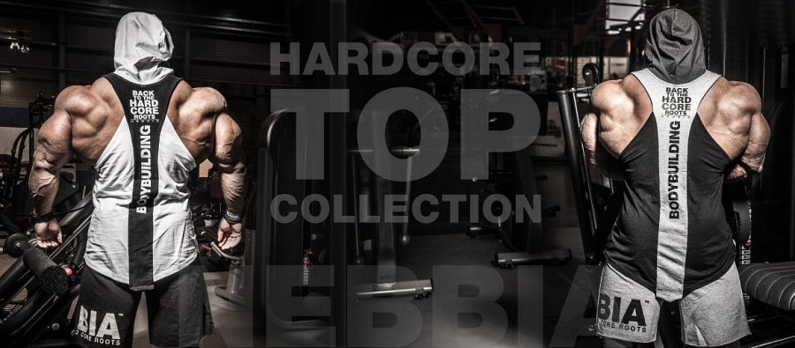

And it's fully understandable, really - so the trainng clothes that we are making right now combine functionality and reliability of usual technical clothes but have also tweaked, awesome design.

See more about Nebbia offer here: [nebbiafitness.com](http://nebbiafitness.com/)

