**Gym clothing - in general, awesome!**

**Gym clothing is part of gym lifestyle. And the fact that gym became a lifestyle, means that there is a meaning added to the clothes you are wearing on top of their functionality as workout clothes. What is it?**

**Gym clothing - why you need that?**

Basically, the looks. As gym became a central point, an eye of the cyclone, and the whole lifestyle is currently revolving around it and people get sucked into it - to put it metaphorically, but not suggesting that there is something wrong about this lifestyle, no, no - but that there is something fascinating about pursuing the streghth and surpassing one's own limitations in the space of gym.

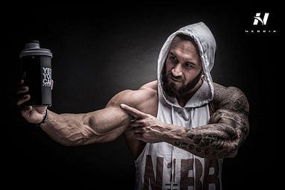

**Nebbia is here for you**

But also, it's double fun to do this in the social context - and for this, you need special tools - **gym clothing** is a whole toolbox of what's possible to choose from, and to create your own appearance.

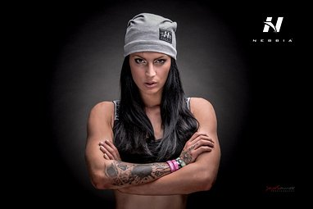

Nebbia Fitness understands all of this - not only the need for *gym clothing* to be realibale, but also to look dope - see what we've preparedso far in this meaning.

See more details here: [nebbiafitness.com](http://nebbiafitness.com)