**Gym clothing from Nebbia Fitness**

**Gym clothing - who needs a dedicated clothes for their workout, anyway? Well, the answer is, all those who do take their gym commitment seriously, more than usual, really. How does it work, though?**

**Some gym clothing from Nebbia Fitness**

Well then, if you are just starting your gym routine, **Nebbia Fitness** is there for you - there is no really a set of must haves you simply need to have in order to start well. An opinion goes around, that when only beginning, it's the motivation to keep going, no matter whether you feel like on a particular day, is paramount.

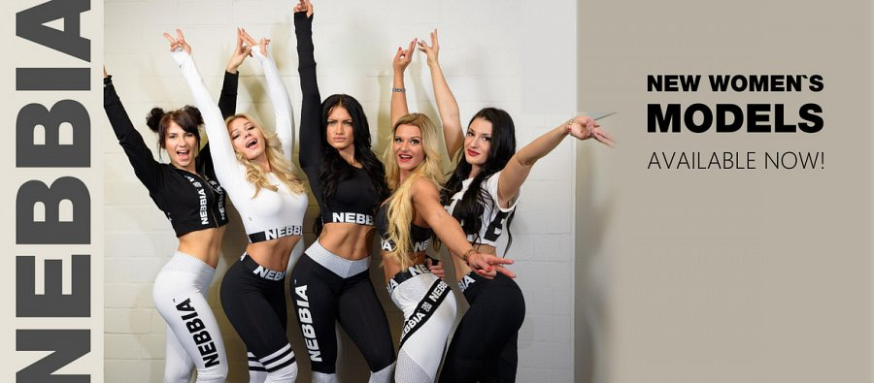

And only after some time, when some motivation crises have been gone through already, an entirely differnet world opens - a one of fine clothes, being in need to get them and use for the benefit when going to the gym.

**Therefore, if you are...**

Only then it really does make sense to try to sell to the people - to convince them to invest - to make them realize that with dedicated gym clothing, like those offered by *Nebbia Fitness*, it's going to go better - there is more satisfaction to be gained.

[nebbiafitness.com](http://nebbiafitness.com/)

