**Salmon high waisted leggings with mesh- what to wear them for?**

**Wondering what to wear salmon color? On the example of salmon high waisted leggings with mesh, we suggest how to combine this ultra-trendy color.**

**Salomon - ultra trendy color**

Salmon is next to powder pink one of the most popular colors of the last seasons. In winter, we wore it on sweaters, sweatshirts or t-shirts, also as a color of accessories, belts or bags, it worked well. In the summer, salmon has become popular in the use of the creation of the so-called total look. We carry this color from head to toe. [**Salmon high waisted leggings with mesh**](https://nebbiafitness.com/en/leggings-pants/2439-high-waist-mesh-leggings-model-n601-salmon-nebbia.html) will look great with a blouse or blouse in exactly the same color. But not only!

**Salmon high waisted leggings with mesh**

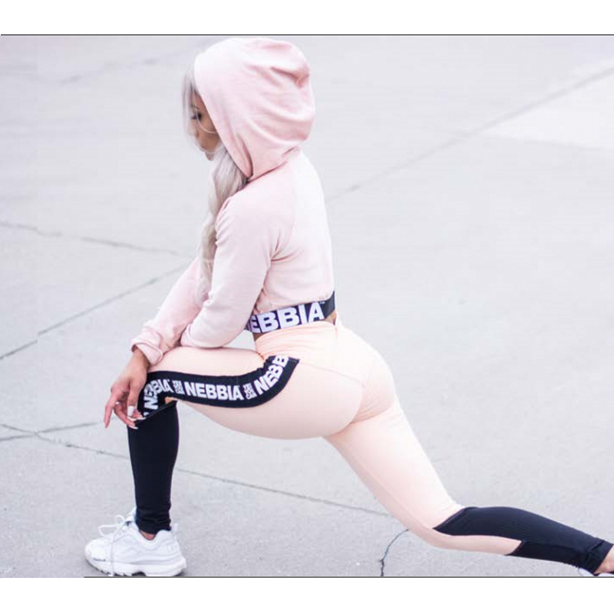

**Salmon high waisted leggings with mesh** is a model of sports leggings, which is designed in this way to model a female figure. The high level not only lengthens the legs but also hides the protruding belly, while emphasizing the waist. Leggings have black elements, thanks to which they will perfectly present themselves with a black t-shirt or sweatshirt. Also with white and pink sports pants will look phenomenal. Interestingly, the pants can be successfully used at the gym, but also outside of it you can combine them.