**Gym clothing - 101 of a good choice**

**The first and foremost important thing in gym clothing, it its reliability - and how well are you going to feel, wearing it - since the practical approach towards technical clothes pays off, and is a definite must when it comes to certain types of activities.**

**Gym clothing - what features to look out for**

So, what type of **gym clothing** you need to choose in order to be ultimately satisfied? Well, there are but several criteria - and one of these is the type of material.

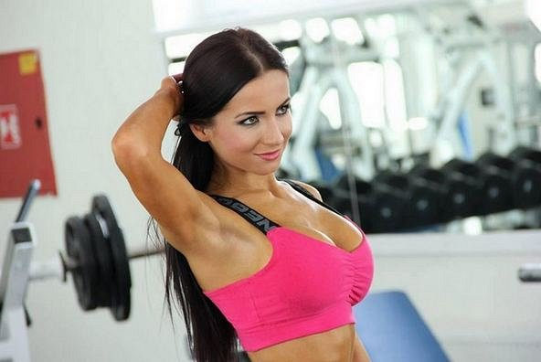

For more details about certain types of Nebbia *gym clothing*, for instance, leggings, seamless leggings, and so on, check out our homepage, with e-commerce online store in it, where product details are storaged and made visible.

**Design for you**

What else? The design - how a particular instance of **gym clothing** is made, and whether wearing it will be acutally comfortable.

It's extremely important, this thing - therefore - Nebbia has been learning for more than 10 years now of its market existence and we invited a number of bodybuilding and fitness personas for consultation and recommendation of our product.

Click here for more: [nebbiafitness.com](http://nebbiafitness.com/)

