**Shorts nebbia n266 lila - best for spring**

**Are you looking for sports clothes for spring and summer? Shorts nebbia n266 lila and other products from Nebbia offer are certainly something for you.**

**Nebbia - sports clothes for women and men**

Nebbia Fitness is an exclusive brand that specializes in the production of sportswear for women and men. Modern design, fashionable colors and perfect materials for exercise are the most important attributes of Nebbia clothing. In the catalog you will find sports leggings, blouses, sweatshirts, sports underwear as well as a wide selection of shorts. Our favorite model is **shorts nebbia n266 lila**. We are convinced not only by the original color but also by the great cut, of these shorts.

**Shorts nebbia n266 lila - how to wear them?**

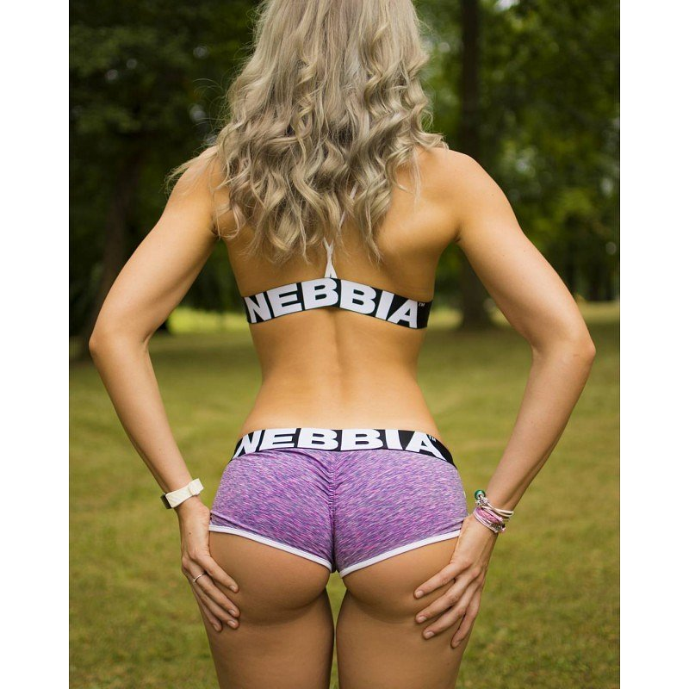

Lila is one of the most fashionable colors for the spring and summer season in 2019. What to combine it with? You can create a colorful total look, i.e. wear shorts with a sports blouse or sports bra, also in lilac color. [**Shorts nebbia n266 lila**](https://nebbiafitness.com/en/shorts/1880-shorts-fitness-model-n266-lila-nebbia.html) will also match gray, black, white or navy blue and pink. Check out the latest Nebbia catalog and choose sports clothes that perfectly match your taste! You will certainly find many attractive models of running clothes or gyms.