**Leggings N222 melange from Nebbia Fitness store**

**Do you know the nebbia fitness brand and their products, e.g. leggings N222 melange? You can find more information about them in the article below!**

**Sportswear - leggings and other**

Every girl and a woman in every age knows, that there are moments in our lives when we need to not only look beautiful but also feel very comfortable. in what we wear. One of such moments is doing any sports exercises, whether running, yoga, crossfit or a visit to the gym or fitness classes. It will just be bad for us to practice in too big sports pants, without a sports bra or in a cotton T-shirt, which is not breathable as well as materials adapted to the production of sportswear. The question is, however, whether in the 21st century there are things on the market that will both be comfortable and look nice? Of course they are! For example, [leggings N222 melange](https://nebbiafitness.com/en/leggings-pants/2447-leggings-melange-model-n222-dark-grey-nebbia.html) from the Nebbia Fitness collection!

**Leggings N222 melange offered by Nebbia Fitness**

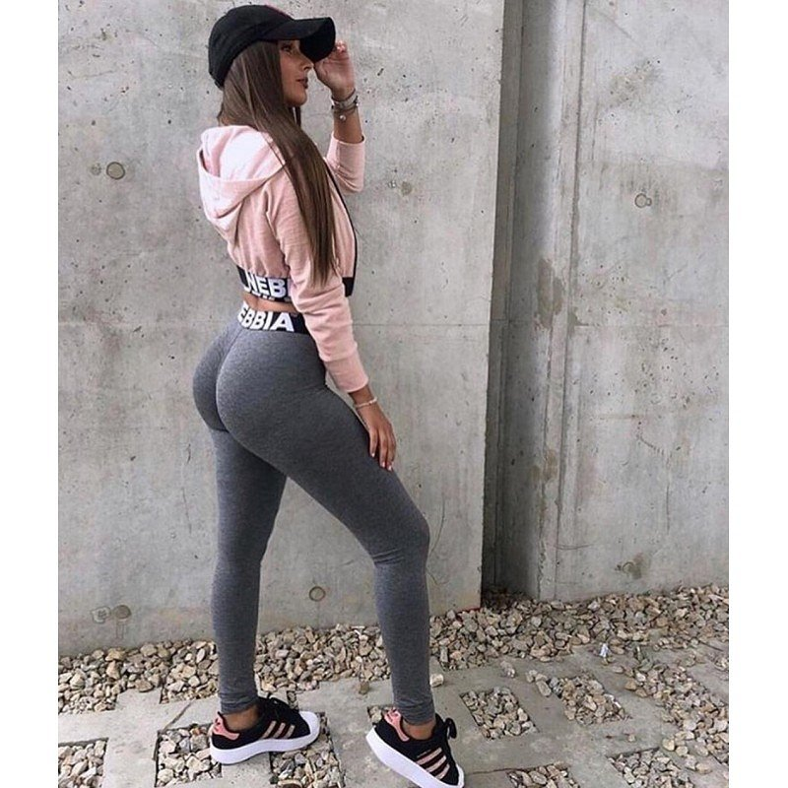

It is obvious that since we devote so much time to sculpting our body and maintaining the health of our body, then we also just want to present ourselves nicely. At the same time, without sacrificing our comfort and convenience while performing exercises, figures, fast running or other activities. And this allows us to the sports range, which offers the renowned brand Nebbia Fitness. **Leggings N222 melange** made of pleasant to the touch material is just one example, it's worth getting to know all Nebbia products and find the perfect one for you!