**Trousers nebbia n251 - best for summer time**

**Are you looking for pants that will be perfect for spring and summer? In which you will be able to go to the gym and also during a normal day? Trousers nebbia n251 will be perfect.**

**Nebbia Fitness brand**

Nadia fitness is a brand that was created based on worship for sport. In our clothing collection every year you will find both men's clothing which women's clothing, which you will successfully use to practice all kinds of sports. We particularly recommend the **trousers nebbia n251**. Check why.

**Trousers nebbia n251 - sporty leggins**

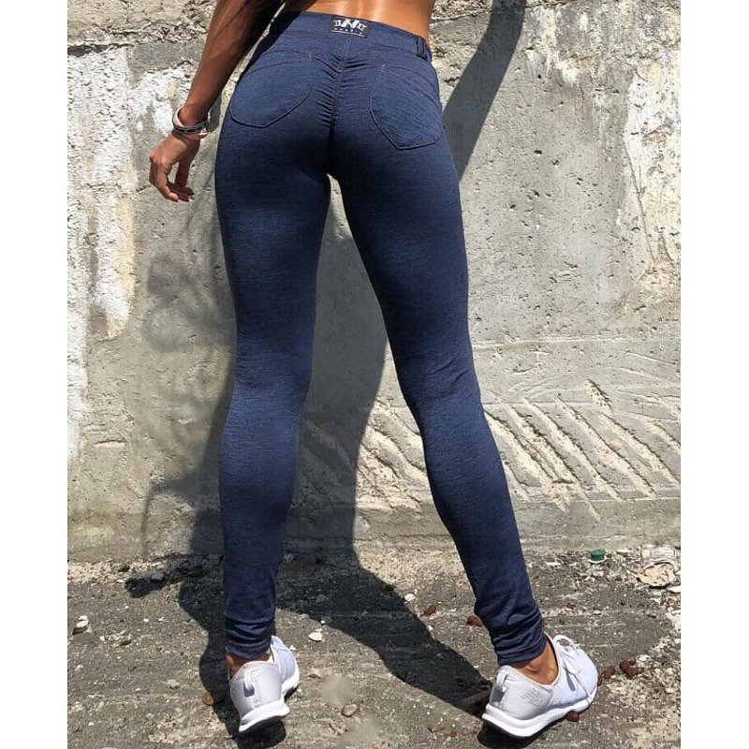

Leggings are one of the most fashionable models of sports pants this season, but not only. Many girls decide to wear leggings not only at the gym or during fitness or yoga classes but also every day. Why? Because they are very comfortable, in addition a model like[**trousers nebbia n251**](https://nebbiafitness.com/en/leggings-pants/1571-trousers-bubble-butt-push-up-model-n251-blue-nebbia.html) is sewn in a specific way, which models our body raises the buttocks and the material used for the production of nebbia trousers fitness massage your body, diminishing cellulite and making your skin more elastic! What's more the model n251 is in navy blue imitating jeans, therefore you can use it in virtually any situation and be sure that it will be more comfortable than in your favorite jeans