**Grey tshirt model n120**

**Men's gray tshirt model n120 is part of the offer of the Nebbia Fitness brand for 2020. Check what we think about him in the article.**

**Tshirt and other parts of gym outfit**

We live in a time when men pay more attention to their appearance. We are not talking only about the fact that men have fallen in love with fashion, but also about the fact that they care about their figure. To maintain a healthy appearance, men often use the gym or swimming pool, or organized crossfit hare or boxing or martial arts. Each of these activities requires a suitable sports outfit. And considering that we spend so much time on a visit to the gym or other activities, it is also good to look good then. That is why men are increasingly investing in good-quality sportswear that at the same time highlight the strengths of their bodies. One such product is a [**gray tshirt model n120**](https://nebbiafitness.com/en/t-shirts-singlets/2284-t-shirt-model-n120-grey-nebbia.html) from the Nebbia Fitness company offer.

**Grey tshirt model n120**

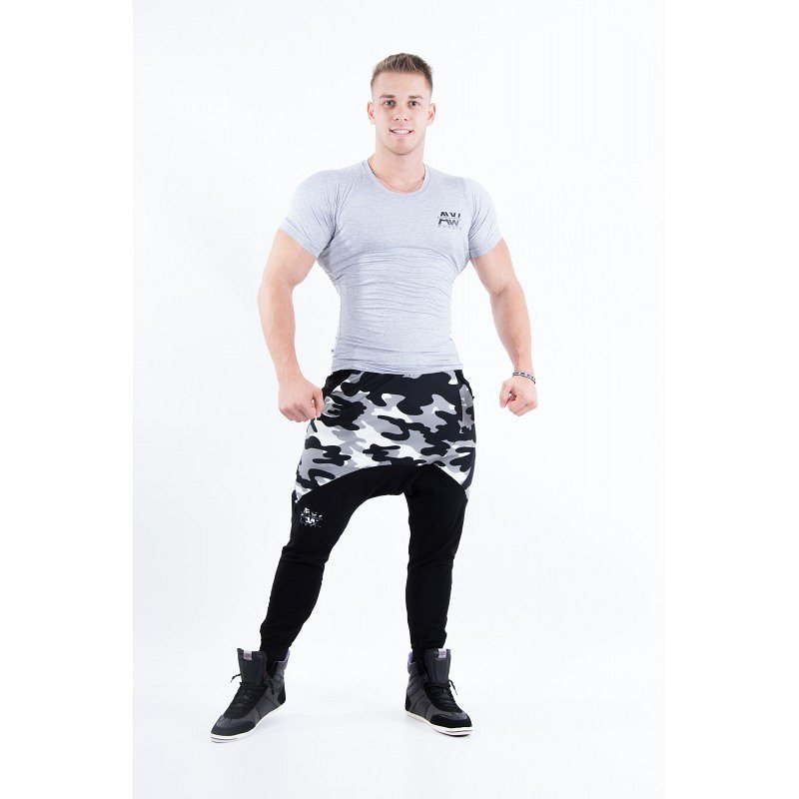

T-shirt in fashionable gray color can easily be combined with sports sweatpants or shorts, creating the perfect outfit for the gym or crossfit. **Gray tshirt model n120** consists of 88% polyamide and 12% elastane, thanks to which it will perfectly match your trained figure, emphasizing it. If this effect interests you, we encourage you to check the offer to buy this shirt on the Nebbia website. Check also other interesting items from the clothing catalog of this brand