Nebbia Fitness | our gym clothing
Nebbia Fitness is your manufacturer of gym clothing. Bodybuilding as well as other gym sports have been our passion for years now, and our business goal was providing the products for those who share this passion.

Nebbia Fitness - an introduction to the brand
The gym clothing from Nebbia Fitness was designed by those who do love sports, manufactured with the utmost care for the details and the quality of the final product, as well as tested thoroughly and recommended by the professionals who, better than anyone, understand, how important fine clothes are for the workout.

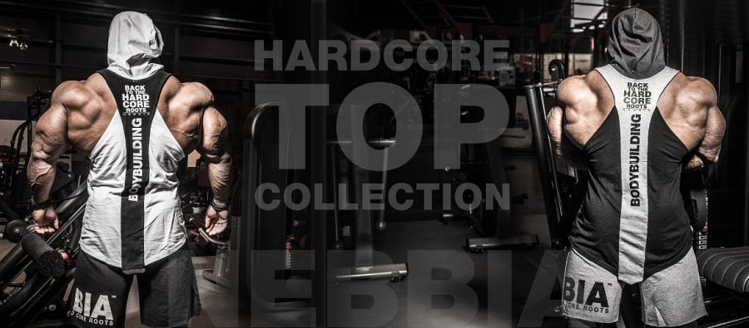
So, if you are looking for the finest gym clothing possible, there may not be a better and more affordable at the same time, choice than Nebbia Fitness.
Considering options?
Therefore, if you are still considering options, look closer at Nebbia Fitness offer, and find something for you there - see the enclosed link and trust the brand that has been around for you, on the market, for over 20 years now, which proves that the quality made and sold is solid, and the designs are the most fresh ones you can find in the gym.
nebbiafitness.com

